Tasting Notes
2020 Willamette Valley Early Muscat

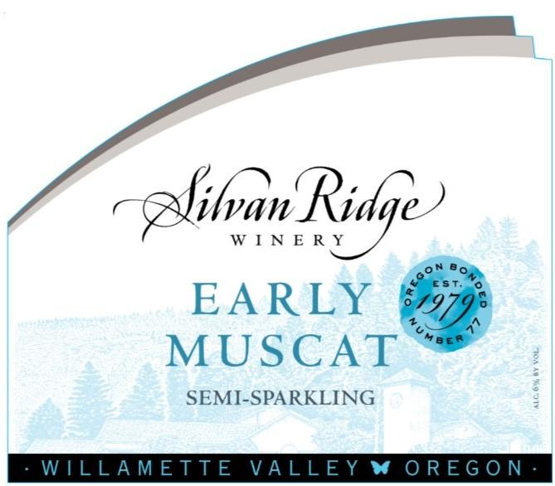

Flavor Profile: This light, fun and bubbly wine has aromas of lychee tea, peach, and mandarin orange. The drink continues along that line with tropical flavors and more peach and citrusy acidity to keep it luscious but balanced.
Pairings & More…
Cheese
Goat, Cornish Blue
Appetizer
Thai Spiced Scallops
Dessert
Mascarpone Tart, Cheesecake

Muscat Mule
Pour 1.5 oz. of your favorite vodka and 4 oz. of Early Muscat into a copper mug.
Add ice and a twist of lime.

Appellation: | Willamette Valley
Varietal Blend: | 100% Early Muscat
Harvest Date: | October 2020
Alcohol: | 6.0%
Residual Sugar: | 10%
Release Date: | May 2021
Cooperage: | 100% Stainless
Production: | 2,400 cases

