Tasting Notes
2020 Willamette Valley Riesling

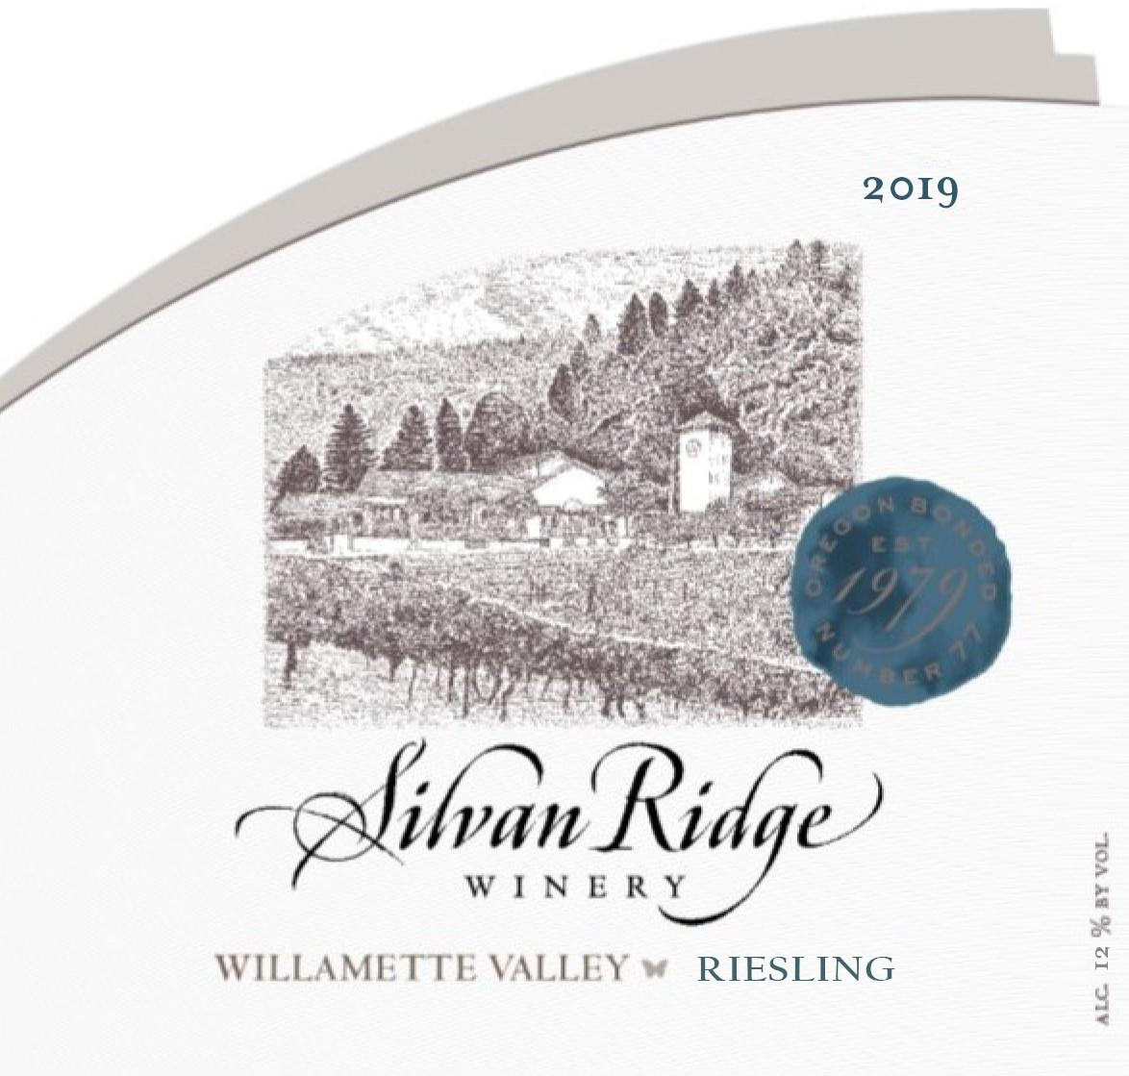

Flavor Profile: This single vineyard Riesling has intense aromas of orange blossom, lemon and apricot. Bright acidity on the palate with flavors of white peach and pear. The finish is clean and crisp, with a hint of minerality, making this wine a perfect companion for summer salads, cheeses and seafood dishes.
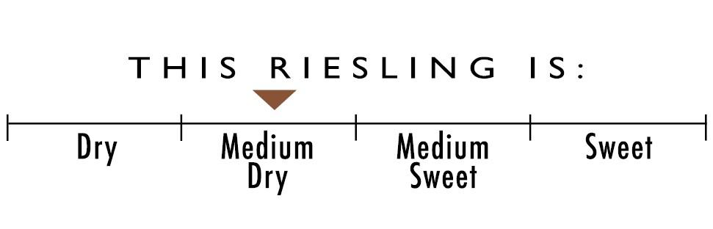

Appellation: | Willamette Valley
Varietal Blend: | 100% Riesling
Harvest Date: | October 2020
Alcohol: | 12.0%
Residual Sugar: | 0.24%
Final pH | 3.04
Total Acid: | 8.2 g/L
Cooperage: | 100% Stainless
Production: | 250 cases

