Tasting Notes
2013 Rogue Valley Viognier

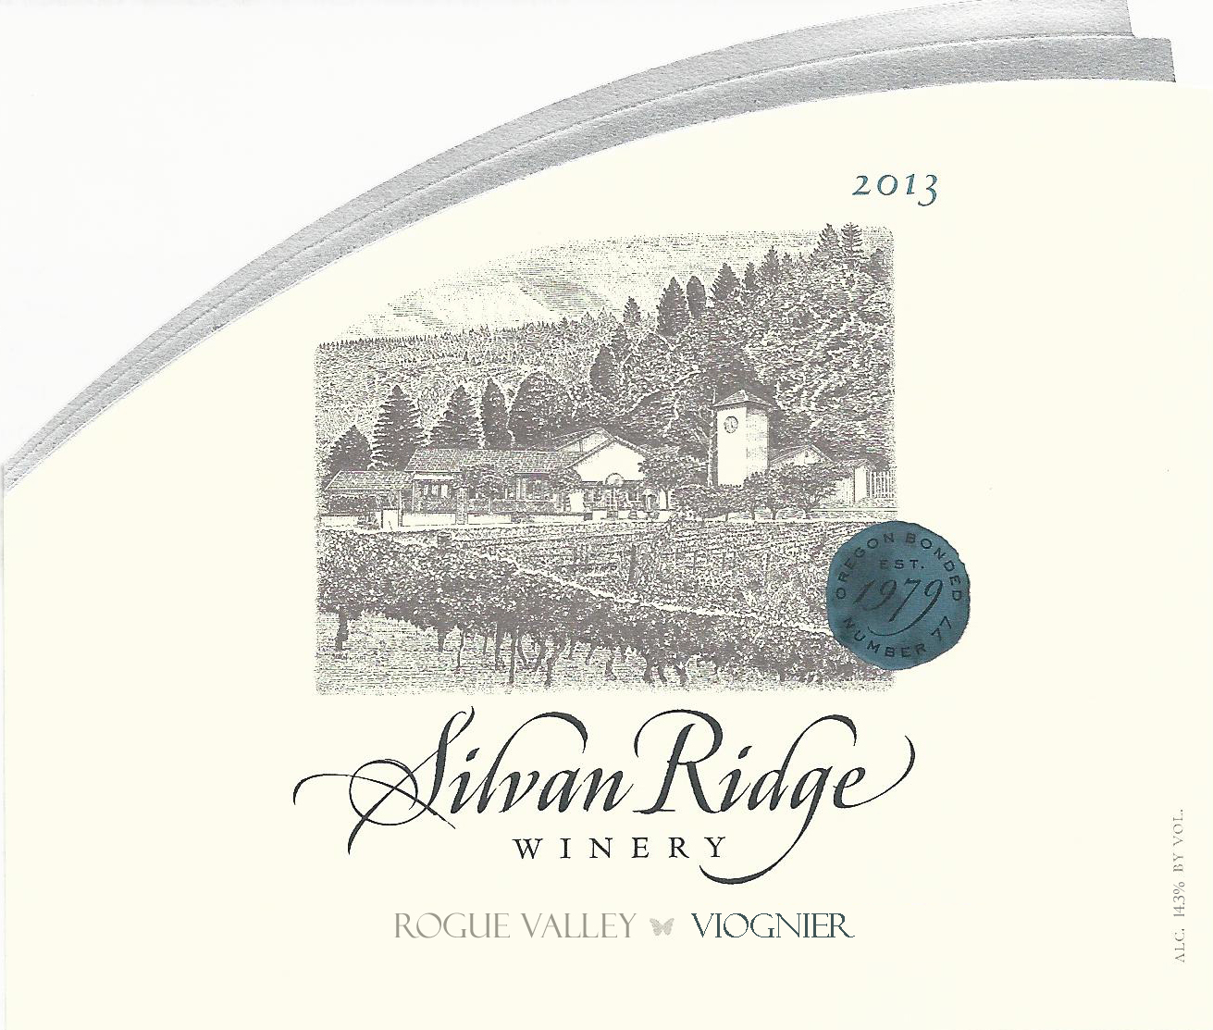

Flavor Profile: Known for having intense, floral aromatics and rich, tropical flavors on the palate, it pairs wonderfully with spicy dishes such as yellow curry.

Appellation: | Rogue Valley
Vineyards: | Daisy Creek & Agate Ridge Vineyards
Varietal Blend: | 100% Viognier
Harvest Date: | September, 2013
Alcohol: | 14.3%
Residual Sugar: | 0.01%
Cooperage: | 100% Stainless
Production: | 413 cases

